NOTE: UPDATE ALL THE HIGHLIGHTED AREAS WITH DETAILS FOR YOUR COUNTY

<Your> County 2022 Voter Log Has XXX Instances of the Williamson County ERROR!
Investigators in Williamson County, Tennessee reviewed the system log (SLOG) files which keep a diary of the scans of ballots for the election. The investigation showed multiple instances of an error called a “QR code Signature mismatch” with a warning message of “Ballot format or id is unrecognizable”. Testers noticed that the machines counted the votes properly until the error was triggered. After the error was triggered, the current ballot in the machine was not counted and every ballot after it was not counted - until the machine was reset. This error was replicated and substantiated by the U.S. Election Assistance Commission Investigation. To date, this problem has not been fixed in any of the software updates. Read more at https://gaballots.com/evidence/f/scanner-failures-in-georgia-match-the-williamson-error. What does that have to do with <Your> County?
XXX Instances of Williamson error in <Your> County 2022 Election
<your EI group> obtained the SLOG files for the <Your> County 2022 General Election. Below is a screenshot from the SLOG file indicating the software running on the electronic voting system.
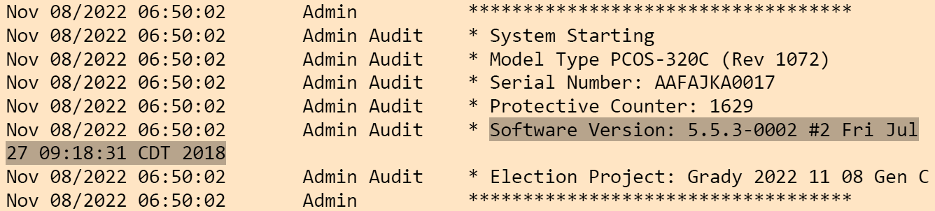
After inspecting the <Your> County SLOG file from 2022 for the error “QR code Signature mismatch”, the search resulted in 769 instances. This error condition exists until the scanner is reset. Download the <Your> SLOG file (SLOGORR.pdf).
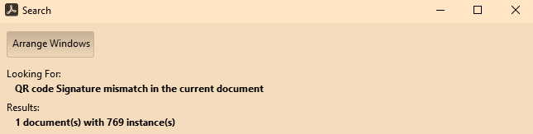
<Your> County and Georgia Utilizing Outdated Unsecure Election Software
Note that the software version above was released in July 2018. Since that time, there have been 4 software updates to correct cybersecurity vulnerabilities and remove the unreadable and unlawful QR code that is tabulated for our votes.
What does this mean for <Your> County? We have an electronic voting system that is too complex and full of holes. The Williamson Error combined with previously submitted <Your> County Petition only increases the voters loss of TRUST. The petition revealed the unlawful QR code which is unreadable to the human eye; lack of software maintenance; and multiple cybersecurity vulnerabilities. We have more than enough reason to abandon and move to a security grade hand marked paper ballot, hand counted at the precinct, like we used to do. Call your County Commissioner, State Representative, State Senator, Lt Governor, and Governor. Get your County Commissioner to call them as well.
For more information, visit www.GeorgiansForTruth.org

